

**Database Week  
San Francisco**

Hands-On Lab: Getting Started with Amazon RDS

February 2019

# Table of Contents

Table of Contents 2

Overview 3

Prerequisites 3

Create an EC2 Key Pair 3

Launch an EC2 Instance as the Web Server 5

Create VPC Security Group for the DB Instance 9

Launch an RDS DB Instance 11

Connect the RDS DB Instance to the Web Server 15

Working with RDS DB Instances 16

Backup and Restore using RDS Snapshots 16

Scale up the Compute Capacity for an RDS DB Instance 19

Monitoring RDS DB Instances 22

# Overview

Amazon RDS is a web service that makes it easy to set up, operate, and scale a relational database in the cloud. It provides cost-efficient and resizable capacity while managing time-consuming database administration tasks, freeing you up to focus on your applications and business.

In this hands-on lab, we will create an Amazon RDS database instance, connect to it using an example web application and learn how to perform basic operations such as snapshots and scaling compute.

The lab includes a few setup steps to ensure all prerequisites are met for you to be able to successfully launch the database instance.

# 

# Prerequisites

In order to successfully provision and use a DB instance there are a few minimum prerequisite configurations and resources that you need to set up.

## 

## Create an EC2 Key Pair

EC2 Key Pairs are used to connect securely to your EC2 Linux-based instances using SSH.

1. Sign into the AWS Management Console and open the Amazon EC2 console at <https://console.aws.amazon.com/ec2>.
2. In the upper-right corner of the AWS Management Console, confirm you are in the desired AWS region (e.g., Sydney).
3. Click on **Key Pairs** in the **NETWORK & SECURITY** section near the bottom of the left-hand menu. This will display a page to manage your SSH key pairs.

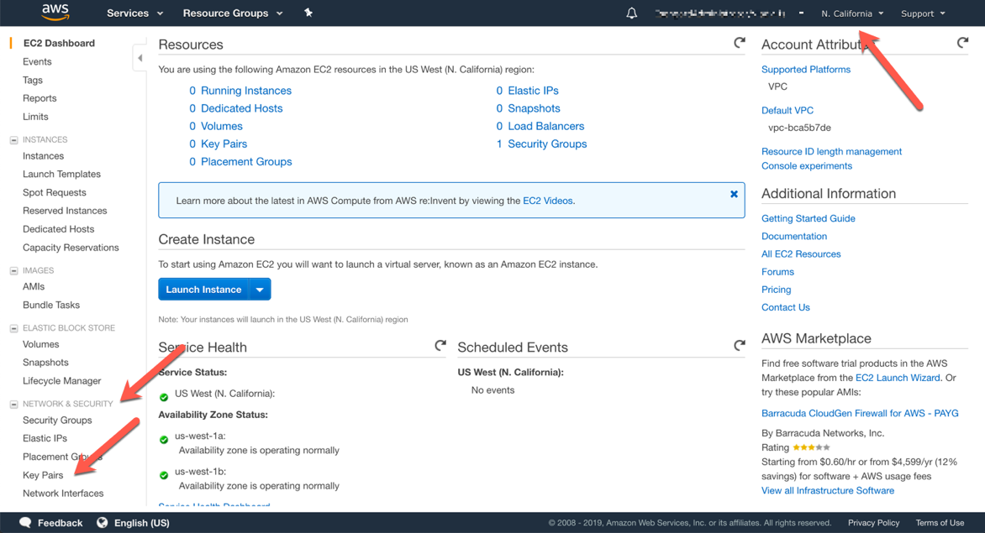

1. Click Create Key Pair.

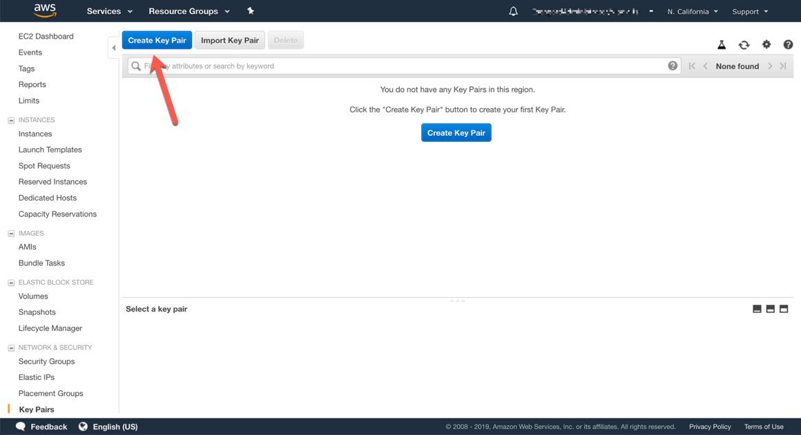

1. Name the key pair “dbweek”, or another memorable name, then click **Create** and download the file with the same name (e.g. **dbweek.pem**) to your computer, save it in a memorable location like your desktop.

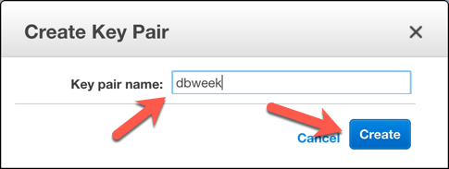

## Launch an EC2 Instance as the Web Server

In this section we will launch an Amazon Linux 2 EC2 instance, bootstrap Apache/PHP, and install a basic web application.

EC2 instances are launched within a [virtual private network](https://docs.aws.amazon.com/vpc/latest/userguide/what-is-amazon-vpc.html) (VPC), configured with the correct topology in terms of network subnets, routing tables, gateways and other network resources. Setting up a VPC is beyond the scope of this exercise. Each AWS account is automatically created with a **Default VPC** in each region, containing a basic network configuration, where resources can be provisioned in any of that region’s availability zones, and can have direct access to the Internet. In rare circumstances, customers can re-purpose these default VPCs, or delete them entirely. If you cannot find the default VPC in your account and region while following the steps in this section, please contact a lab assistant.

1. Sign into the AWS Management Console and open the Amazon EC2 console at <https://console.aws.amazon.com/ec2>, if the console is not already open
2. In the upper-right corner of the AWS Management Console, confirm you are in the desired AWS region (e.g., Sydney).
3. Navigate in the left-hand menu to **EC2 Dashboard** or **Instances**, then click **Launch Instance**.

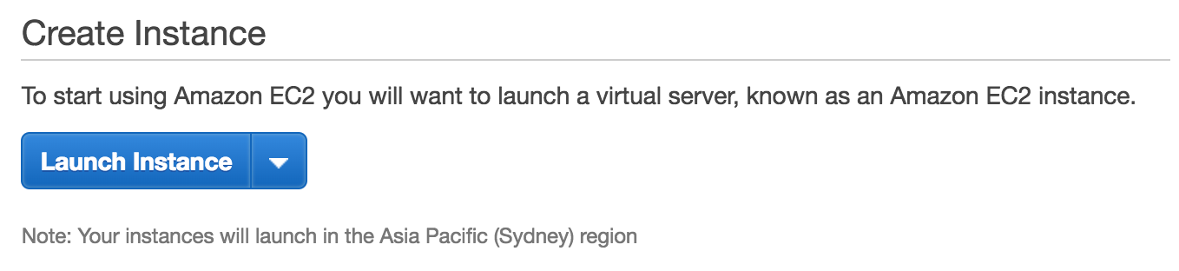

1. In the Quick Start section of Step 1: Choose an Amazon Machine Image (AMI), select the first Amazon Linux 2 AMI (HVM), SSD Volume Type option and click Select.

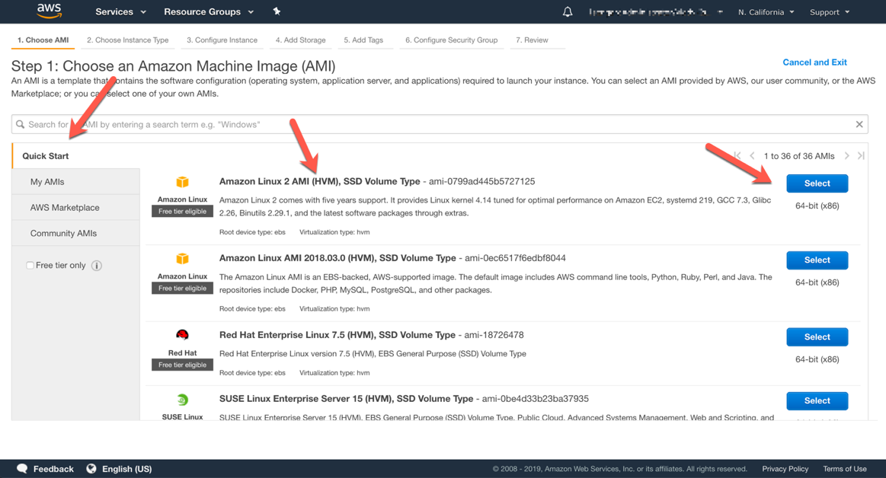

1. On the **Step 2: Choose Instance Type** screen, select the **t2.micro** instance size and click **Next: Configure Instance Details** in the bottom right corner.
2. On the **Step 3:** **Configure Instance Details** screen, accept the defaults, but scroll down and expand the **Advanced Details** section. Copy/paste the script below into the **User Data** field (this shell script will install Apache & PHP, start the web service, and deploy a simple web page). Click **Next: Add Storage** in the bottom right corner.

#include

https://s3.amazonaws.com/immersionday-labs/bootstrap.sh

1. On the **Step 4: Add Storage** screen, you have the ability to modify or add storage and disk drives to the instance. For this lab, we will simply accept the storage defaults and click **Next: Add Tags** in the bottom right corner.
2. On the **Step 5: Add Tags** screen, you can name your EC2 instance by creating a **Name** tag. This Name will appear in the Management Console once the instance launches. It makes it easy to keep track of running machines in a complex environment. Click the **Add Tag** button, write **Name** under the **Key** column,and write a memorable name like “DB Week Web Server” in the **Value** column. Click **Next: Configure Security Group** in the bottom right corner.

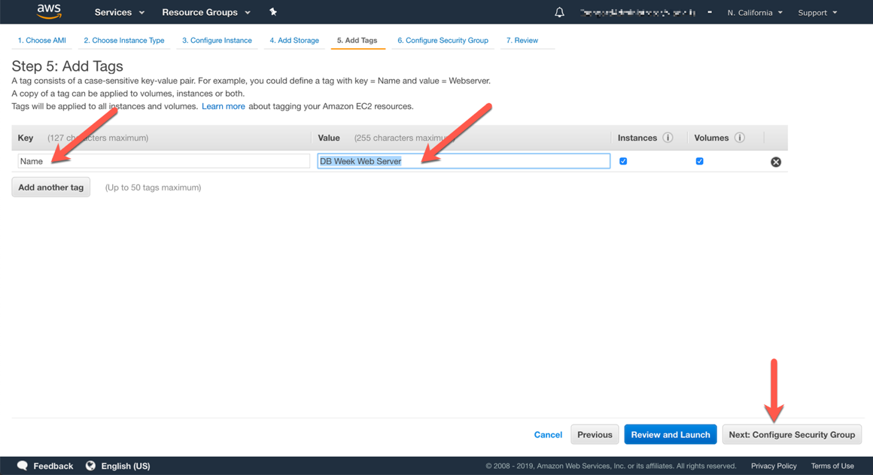

1. On the **Step 6: Configure Security** Group screen, you will be prompted to create a new **Security Group**, which will contain your firewall rules. Since we are building out a Web server, name your new security group “DB Week Web Tier” or a similarly memorable name, and confirm an existing SSH rule exists which allows TCP port 22 from Anywhere (or 0.0.0.0/0). Click the **Add Rule** button, to add an additional rule.
2. Select **HTTP** from the **Type** dropdown menu, and confirm **TCP** port **80** is allowed from **Anywhere** *(you’ll notice, that “Anywhere is the same as ‘0.0.0.0/0’)*. Click **Review and Launch** in the bottom right corner.

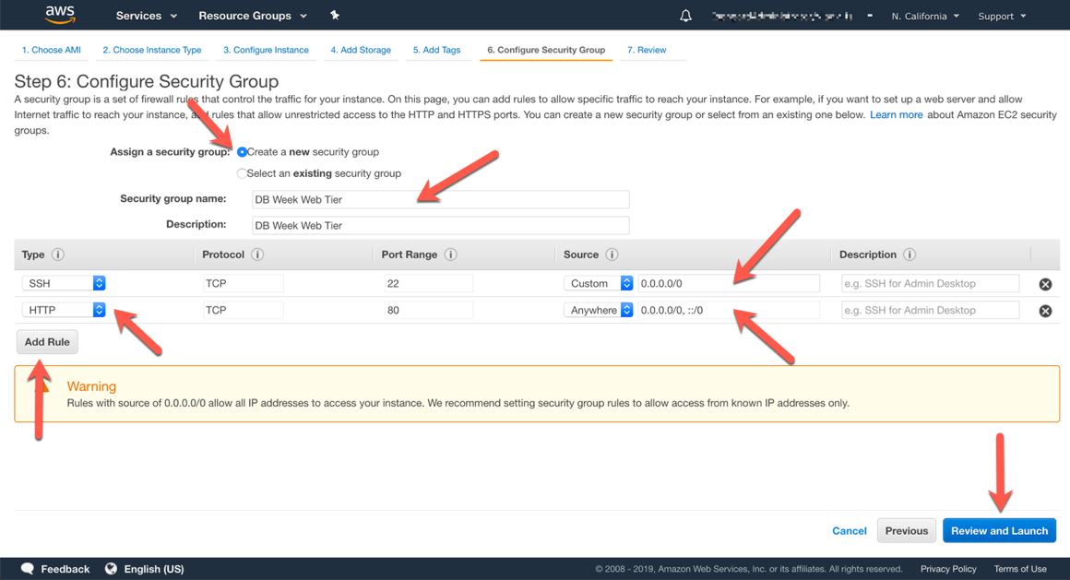

1. Review your cofiguration and choices, and then click **Launch** in the bottom right corner.
2. At the **Select an existing key pair…** prompt make sure to choose the option **Choose and existing key pair** in the first dropdown. Select the key pair that you created in the beginning of this lab from the second drop-down and check the "I acknowledge […]" checkbox. Then click the **Launch Instances** button.

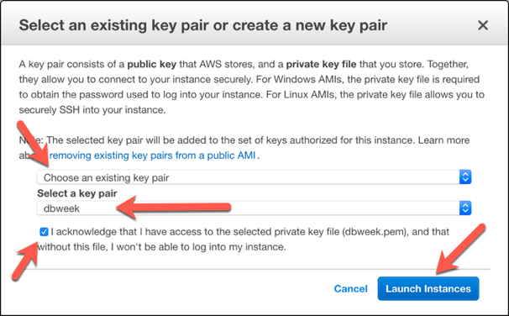

1. Click the **View Instances** button in the lower righthand portion of the screen to view the list of EC2 instances. Once your instance has launched, you will see your web server as well as the Availability Zone the instance is in, and the publicly routable DNS name.
2. Click the checkbox next to your web server to view details about this EC2 instance.

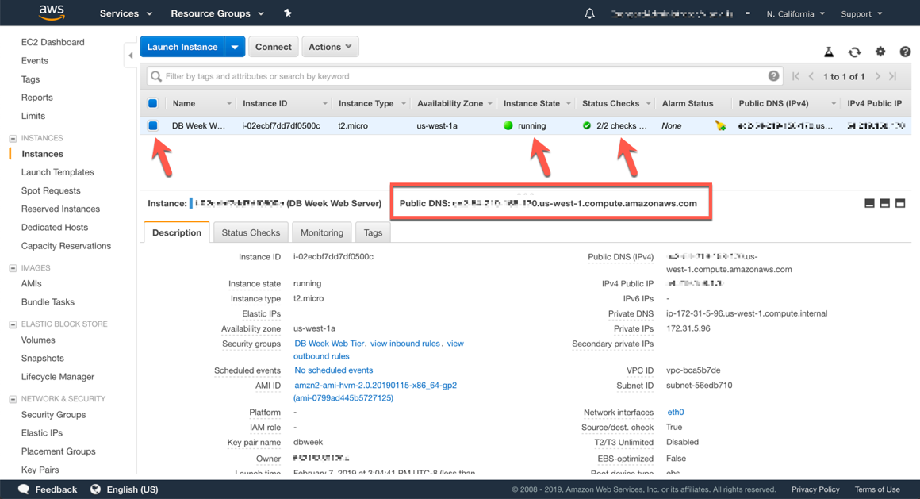

1. Wait for the **Instance state** to change to **running** and to show **2/2 checks passed** in the **Status Checks** column.
2. Open a new browser tab and navigate to the web server interfaces by entering the EC2 instance’s **Public DNS** name into the browser. The EC2 instance’s Public DNS name can be found in the console by reviewing the Public DNS name line highlighted in the preceding screenshot. You should see a website that looks like the example below:

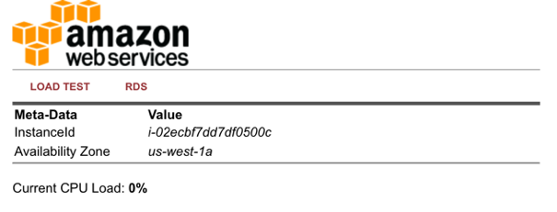

## Create VPC Security Group for the DB Instance

The RDS servers have the same security model as Amazon EC2: trust nothing. A common use of an RDS instance in a VPC is to share data with an application server running in an EC2 instance in the same VPC. In this lab, the web server EC2 instance you just created, can be accessed directly over the Internet, and that web server will then initiate database connections to the RDS DB instance.

To this end, we’ll need to utilize a VPC security group to permit the EC2 instance to access the RDS DB instance. Because workloads in AWS are elastic, and the number of actual EC2 instances typically can change, we will reference the security group of the web server as a permitted source of traffic to the database, instead of the IP address of the web server itself. This ensures that if we decide later to add more web server EC2 instances (or remove some), and we configure them to use the same web tier security group, we do not have to change the database security group to allow access. Access will be granted automatically by the membership in the web tier security group.

Let’s create a new VPC security group for our database tier that only allows traffic from our web server (the EC2 instance we created previously).

1. Sign into the AWS Management Console and open the Amazon VPC console at <https://console.aws.amazon.com/vpc>, if the console is not already open, or showing a different service console.
2. In the upper-right corner of the AWS Management Console, confirm you are in the desired AWS region (e.g., Sydney).
3. In the VPC dashboard, click **Security Groups**, then the **Create Security Group** button.

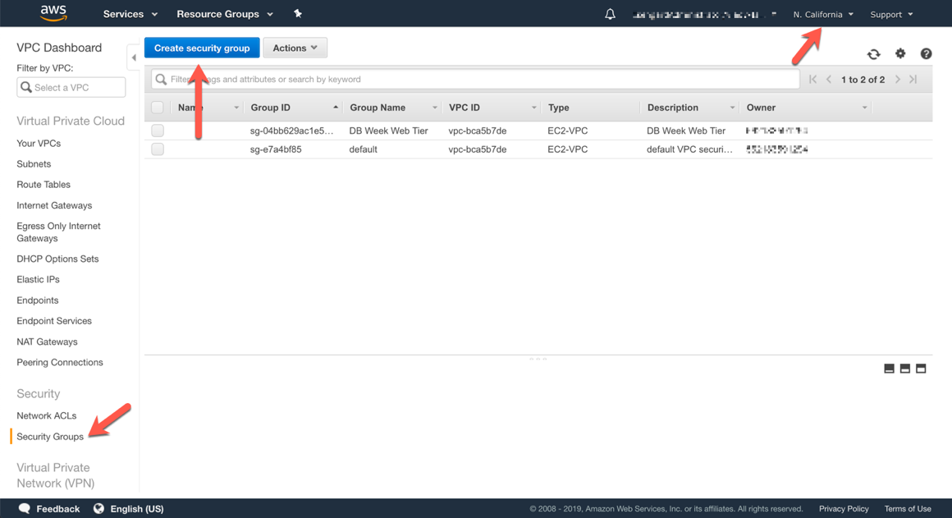

1. Set the **Security group name** and **Description** to a memorable name “DB Week Database”. Under **VPC**, keep the VPC setting to the same VPC you’ve launched your EC2 instance in (typically the *Default VPC* which may be unnamed). Then click **Create**.

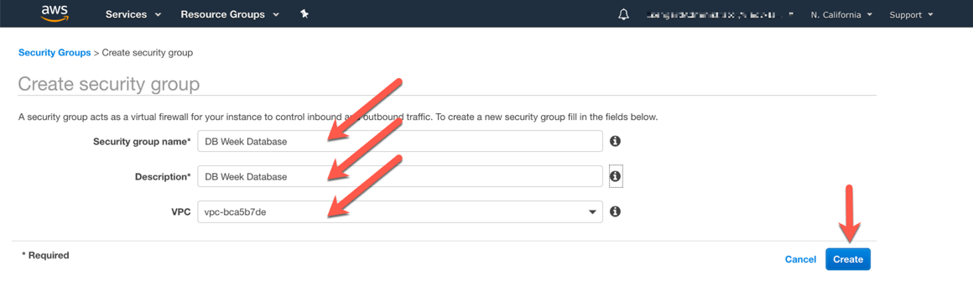

1. After your VPC security group is created (click **Close** on the confirmation screen), you’ll see it listed along with the other security groups in your account. Check the box next to it, to see the details of it in the lower pane on the screen.

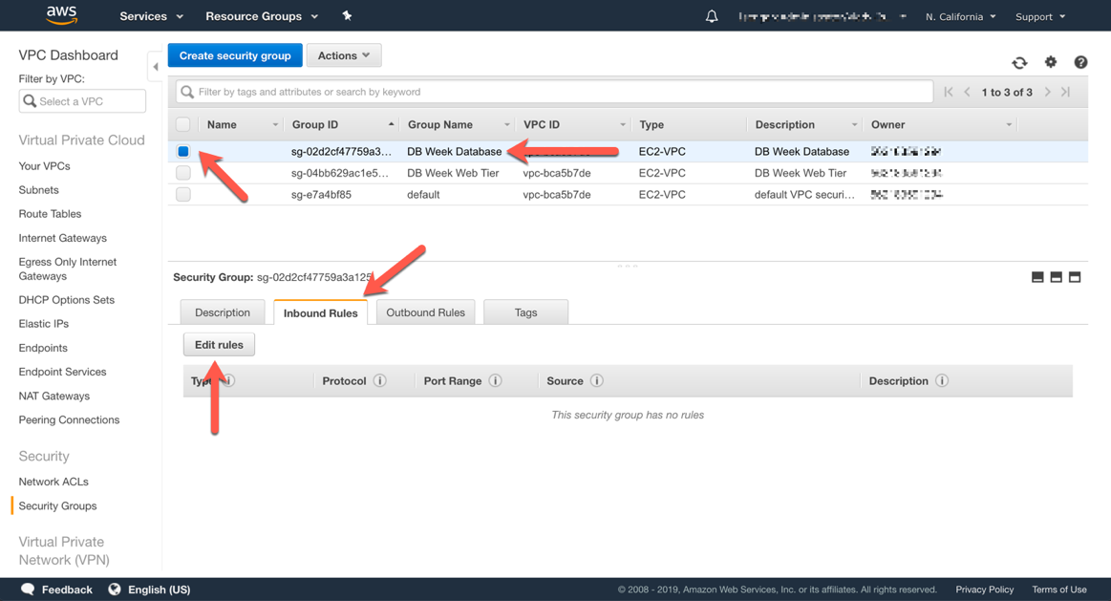

1. Click **Inbound Rules***,* then the **Edit rules** button in that lower pane.
2. Add a new inbound rule for the EC2 server(s) in our web tier by clicking the **Add Rule** button. The **Type** should be **MySQL/Aurora (3306)** which auto-selects protocol **TCP** and port **3306**. In the **Source** text box, start typing “sg-“, while you’re typing, a list of security group(s) that match should be presented to you. Select your web tier security group, then click the **Save rules** button.

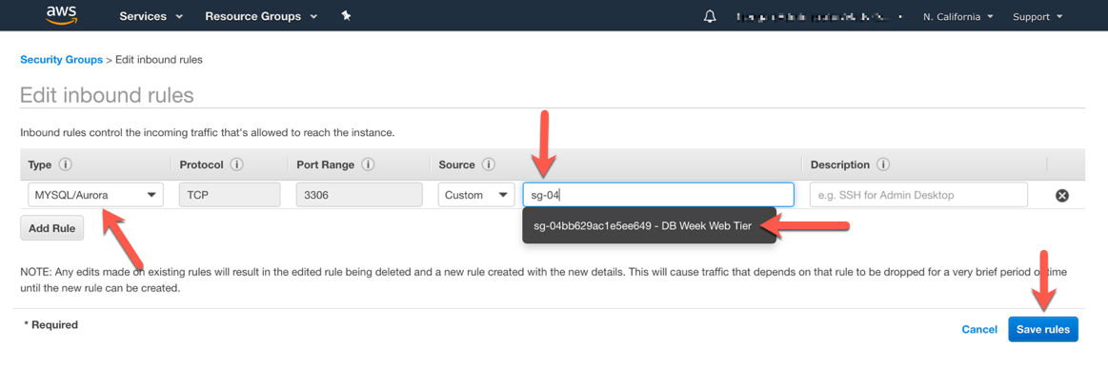

1. Click **Close** on the confirmation screen.

# Launch an RDS DB Instance

Now that all prerequisites are met, you can configure and launch a MySQL RDS DB Instance. For the purposes of this lab, you will use the default configurations where possible.

1. Sign into the AWS Management Console and open the Amazon RDS console at <https://console.aws.amazon.com/rds>, if the console is not already open, or showing a different service console.
2. In the upper-right corner of the AWS Management Console, confirm you are in the desired AWS region (e.g., Sydney).
3. Click on **Create database**.

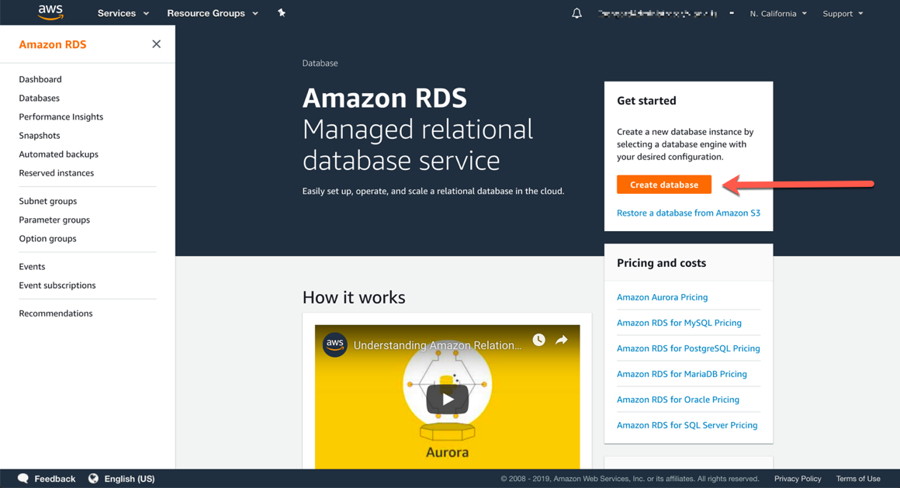

1. At **Step1 Select engine,** choose **MySQL** from the available engine options. Check **Only enable options eligible for RDS Free Usage Tier**, at the bottom of the page. This option is not recommended for production databases, as it will disable options such as Multi-AZ deployments or read replicas, but it is safe for the purposes of this lab. Click **Next** in the bottom right area of the screen.

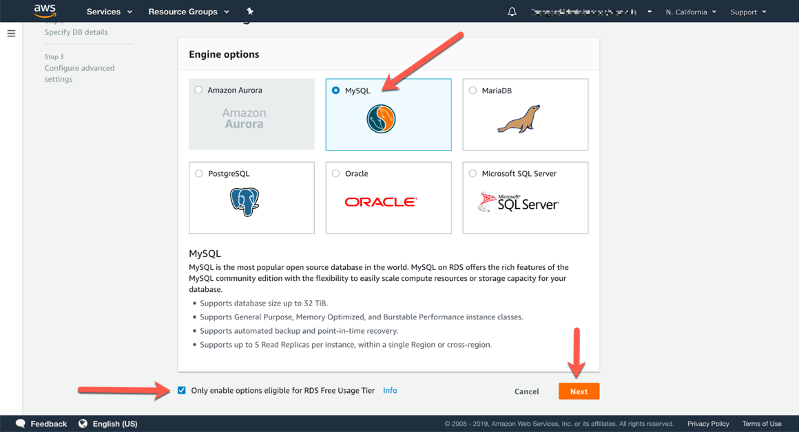

1. At **Step2 DB details,** fill out the DB Instance details with the following information and then click **Next** in the bottom right area of the screen.

* DB engine version: MySQL 5.7.23 (or newer 5.7 minor version)
* DB instance class: db.t2.micro
* Storage type: General Purpose (SSD)
* Allocated storage: 20 GB
* DB instance identifier: dbweek
* Master username: awsuser (or another memorable username)
* Master password: DBweek19 (or another memorable password)

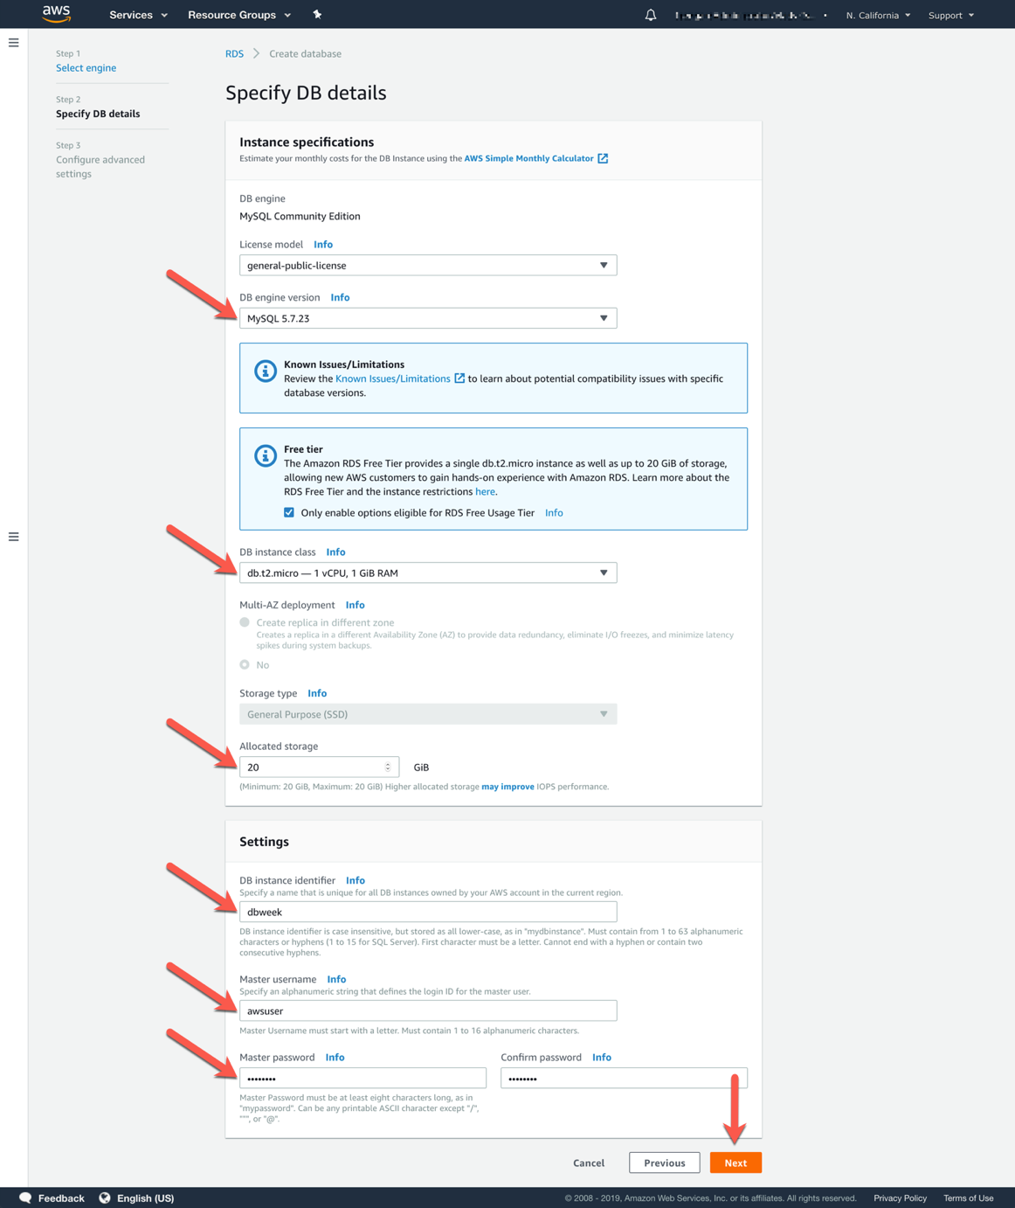

1. At **Step 3 Configure advanced**, fill out the **Network & Security** section with the following information:

* Virtual Private Cloud (VPC): S*elect the one named* **Default VPC**
* Subnet group: default
* Public accessibility: No
* Availability zone: No preference
* VPC security groups: Select **Choose existing security group**, then pick theone you have created previously for the database. Remove the one named **default** by clicking on the **×** symbol.

1. In the **Database options** section, provide a memorable database name, such as “dbweek” (you will need it later).

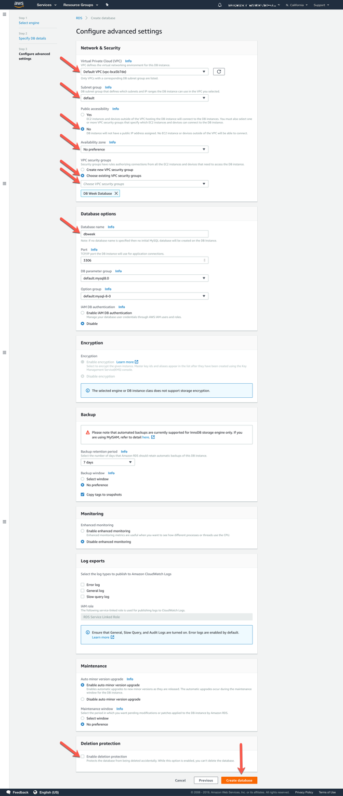

1. Use the default settings for the Encryption, Backup, Monitoring, Log exports and Maintenance sections.
2. Under **Deletion protection**, uncheck the box labeled **Enable deletion protection**. This is usually not recommended in a production deployment, but will simplify your lab deployment.
3. Review your settings and click **Create database** in the bottom right area of the screen.
4. On the confirmation screen, click **View DB instance details** to monitor the provisioning process.

# Connect the RDS DB Instance to the Web Server

The web server previously created contains a script to deploy an example database table and sample data for creating a simple address book. Next, you will connect the web server to the RDS DB instance and deploy that example.

1. While still on the DB instance detail page of the database we recently created, refresh the browser window to ensure the DB instance status is listed as **Available.**
2. Click on the **Connectivity & security** tab if it is not already selected, and check the value under **Endpoint**. This is the DNS name of your database, and you will need it to connect to the database from clients. Copy that value, as you will need it shortly.

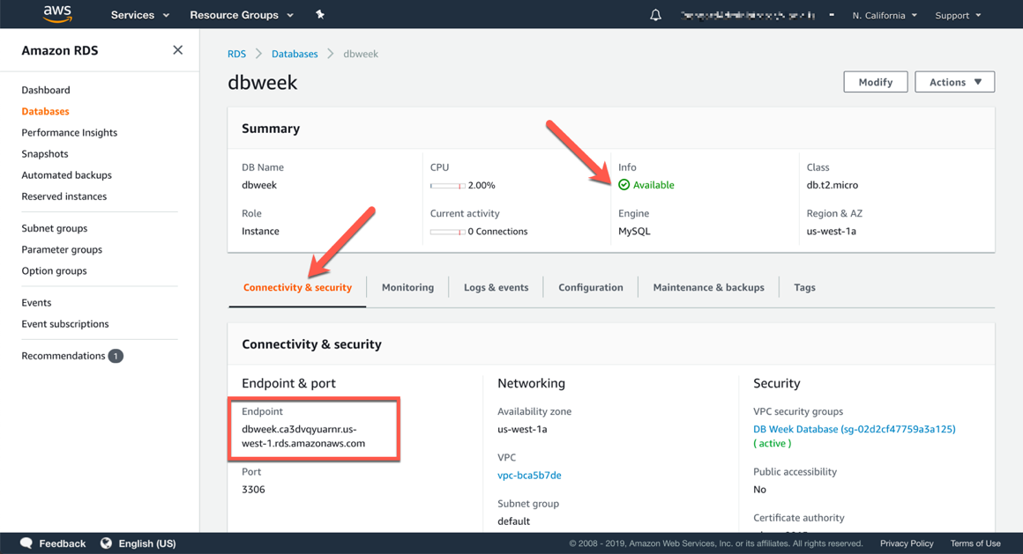

1. Navigate to the browser tab or window where you have the web server interface previously created open. Click on the **RDS** link**.**
2. You should see a prompt to enter the DB endpoint previously copied (do NOT include :3306 at the end of the DB endpoint), as well as the database “dbweek”, username “awsuser” and password “DBweek19”, or the custom values you specified when creating the database. Click the **Submit** button.

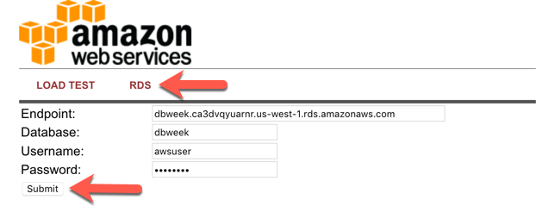

1. When complete, you will be redirected to a simple page displaying all of the information from the database you just created.

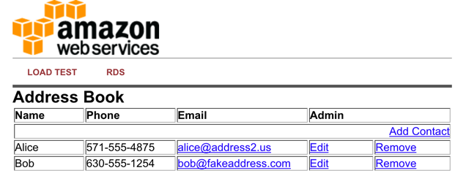

This is a very basic example of a simple address book interacting with a MySQL database managed by AWS. RDS can support much more complicated relational database scenarios, but we hope this simple example will suffice to demonstrate the point.

Feel free to play around with the address book and add/edit/remove content from your RDS database by using the **Add Contact**, **Edit**,and **Remove** links in the Address Book.

# 

# Working with RDS DB Instances

## Backup and Restore using RDS Snapshots

Now is a good time to take a snapshot of your RDS database. Taking a snapshot enables you to back up your DB Instance in a known state as frequently as you wish, and then restore to that specific state at any time.

1. Sign into the AWS Management Console and open the Amazon RDS console at <https://console.aws.amazon.com/rds>, if the console is not already open, or showing a different service console.
2. In the upper-right corner of the AWS Management Console, confirm you are in the desired AWS region (e.g., Sydney).
3. In the left-hand side navigation panel (the panel may be collapsed, click the three horizontal bars at the top of it to expand it), click on **Databases,** then select the radio box of the row corresponding to your DB instance.
4. From the **Actions** menu button at the top of the DB instance listing, choose **Take snapshot**.

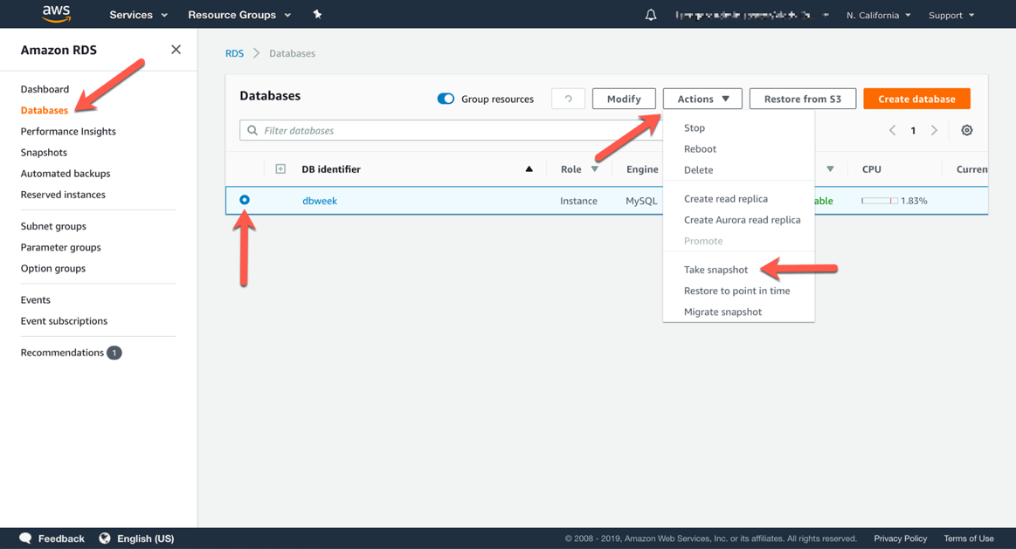

1. Give the snapshot a memorable name, such as “dbweek-snapshot” and click **Take Snapshot**.

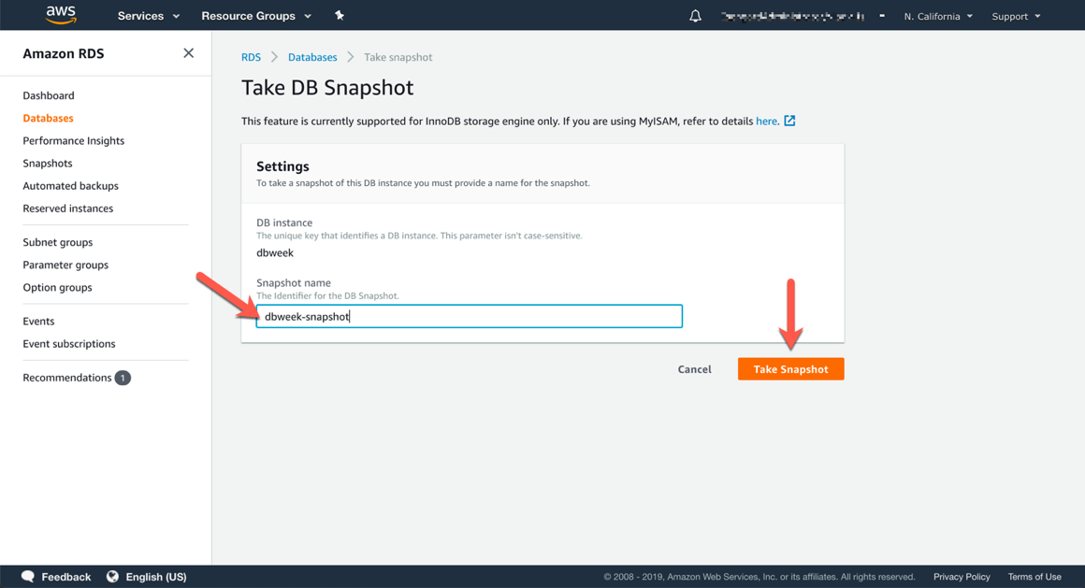

1. You can track the backup progress in the **Snapshots** section of the RDS console. When the snapshot completes it will be listed as **available**. Notice the automated snapshot in the listing. It was enabled automatically when the default of 7 days backup retention was configured at DB instance launch time. You can leverage the automated backups to execute point in time restore operations, up to the last 5 minutes prior to the present time.

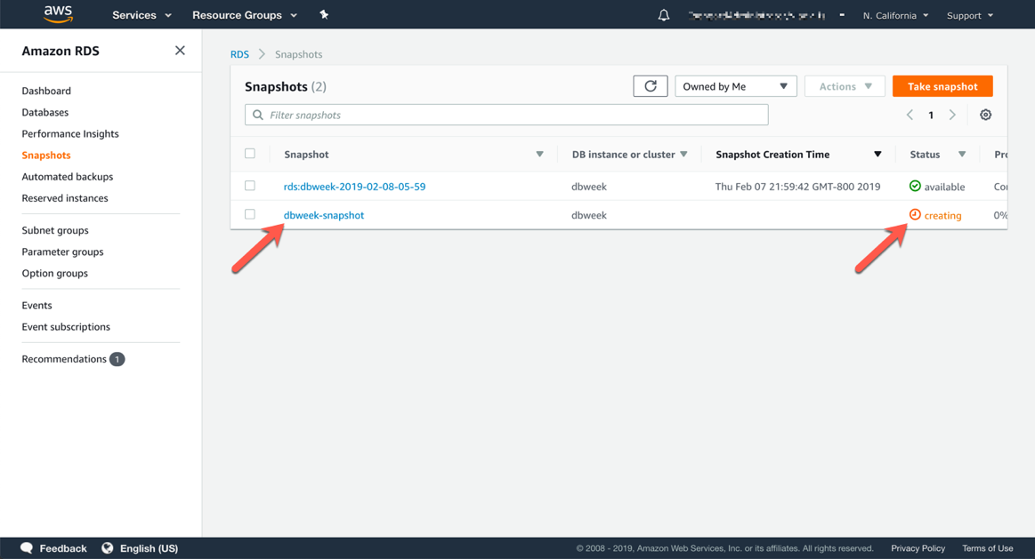

1. Once available, you can use that snapshot to restore the database. RDS does not replace your existing DB instance with the restored one, instead it will create a new DB instance using the data set of the snapshot. To initiate a restore operation, select the desired snapshot, then from the **Action** menu button at the top of the snapshot listing. Choose **Restore Snapshot** then follow the configuration screens. Notice that you can easily launch new RDS instances from any previous snapshot!

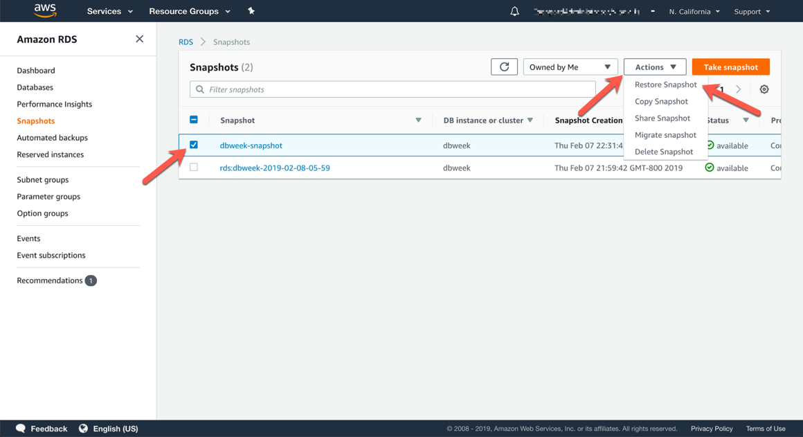

## Scale up the Compute Capacity for an RDS DB Instance

Scaling up and down with RDS is simple via the AWS Management Console. You can change the underlying server size, by selecting a new DB instance class, and you can modify the storage characteristics, by changing the storage type and growing the size of the storage to accommodate usage growth. You cannot shrink the size of the storage, however, if it turns out you have overprovisioned it. It is always recommended to start with the right amount of storage you need in the immediate future, and scale the storage as your workload grows.

1. Sign into the AWS Management Console and open the Amazon RDS console at <https://console.aws.amazon.com/rds>, if the console is not already open, or showing a different service console.
2. In the upper-right corner of the AWS Management Console, confirm you are in the desired AWS region (e.g., Sydney).
3. In the left-hand side navigation panel (the panel may be collapsed, click the three horizontal bars at the top of it to expand it), click on **Databases,** then select the radio box of the row corresponding to your DB instance.
4. Click the **Modify** button at the top of the DB instance listing.

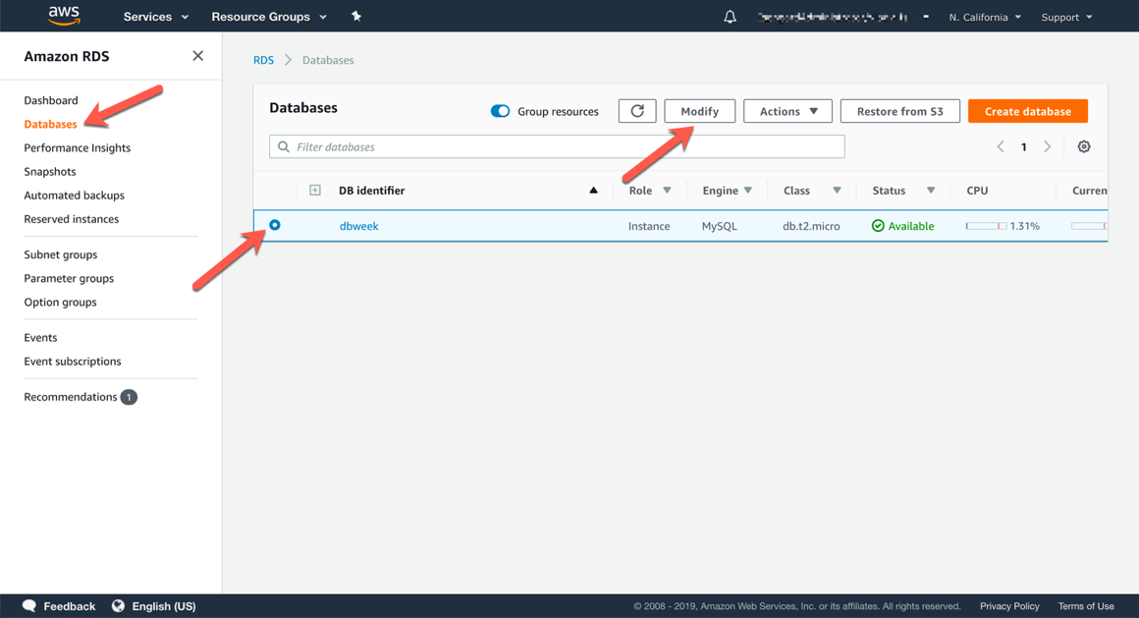

1. On the **Modify DB Instance** screen, try changing to a **t2.large** DB instance class, and if you want, also grow the database at the same time. Click **Next**.

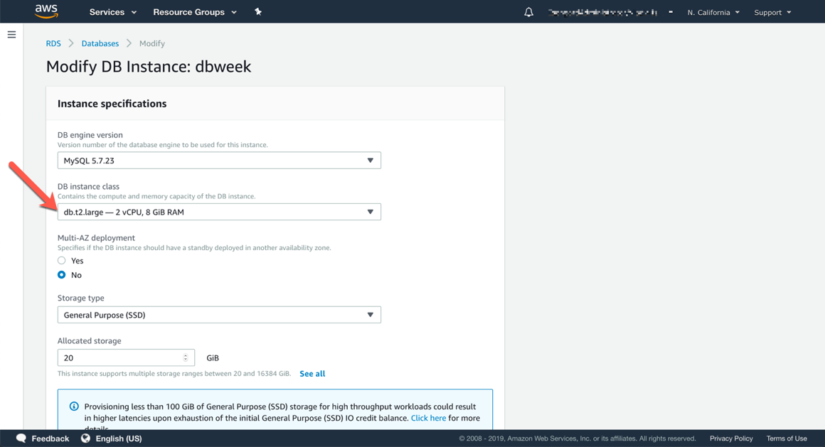

1. On the next screen, don’t forget to choose **Apply immediately.** Then click **Modify DB Instance**.Otherwise changes will be scheduled to be applied during the next maintenance window. Scheduling changes is preferred for production workloads, as some modifications, like changing the DB instance class, require a restart (or failover in case of Multi-AZ DB instances). Applying such changes during a period of low utilization mitigates the corresponding temporary loss of availability.

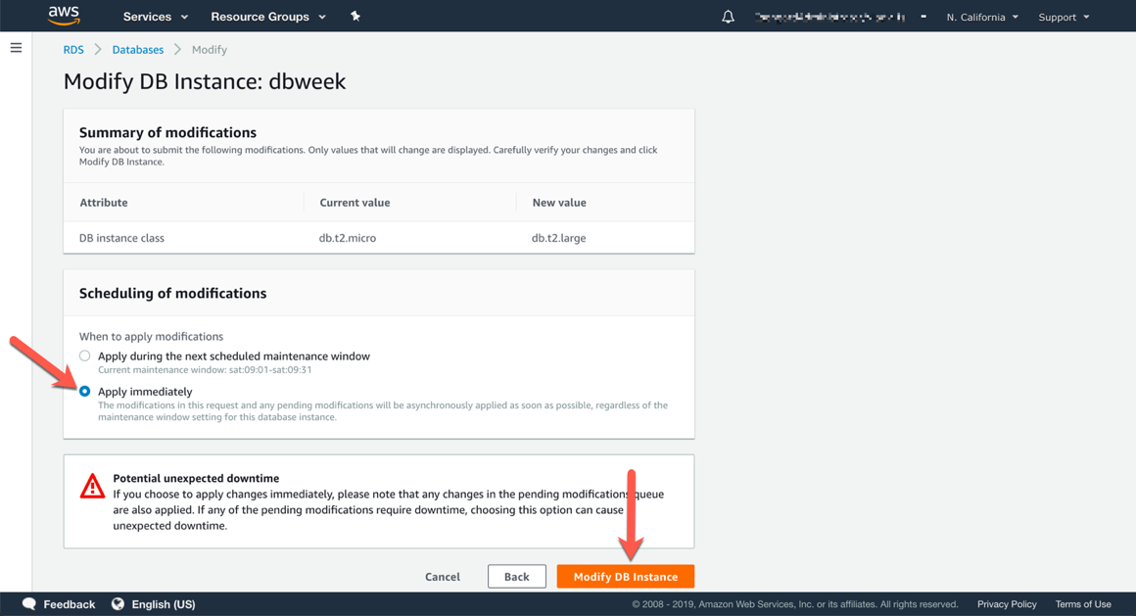

1. Back on the **Databases** listing page in the console, you can track the status of the operation. While the changes are performed, your DB instance will be listed in a **Modifying** state.

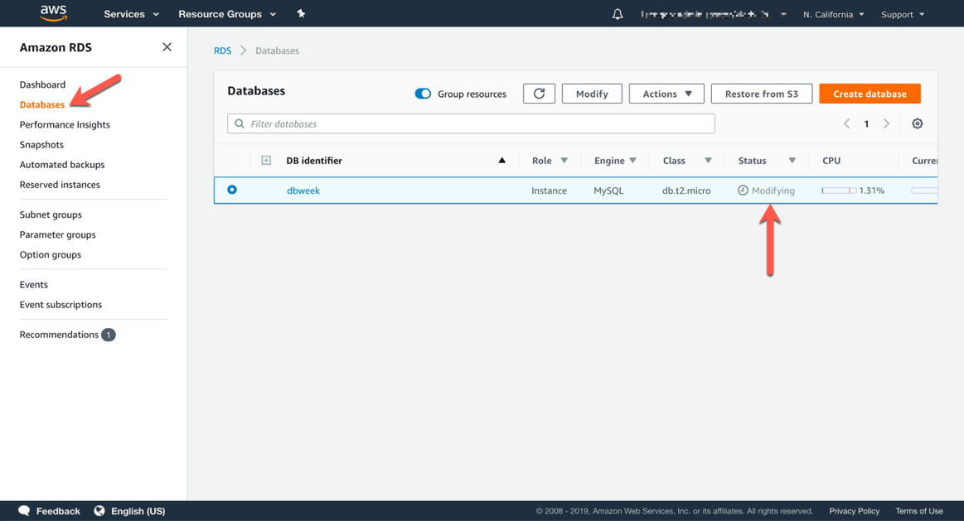

## Monitoring RDS DB Instances

You can monitor the health and performance of your RDS DB instances directly from the console. Amazon RDS leverages Amazon CloudWatch to expose various relevant health and performance metrics. You can use these metrics to monitor, create alarms, troubleshoot or make capacity planning decisions.

1. Sign into the AWS Management Console and open the Amazon RDS console at <https://console.aws.amazon.com/rds>, if the console is not already open, or showing a different service console.
2. In the upper-right corner of the AWS Management Console, confirm you are in the desired AWS region (e.g., Sydney).
3. In the left-hand side navigation panel (the panel may be collapsed, click the three horizontal bars at the top of it to expand it), click on **Databases,** then select the radio box of the row corresponding to your DB instance.
4. Click on the **DB identifier** of the desired database in the list.
5. Click on the **Monitoring** tab on the database detail page.

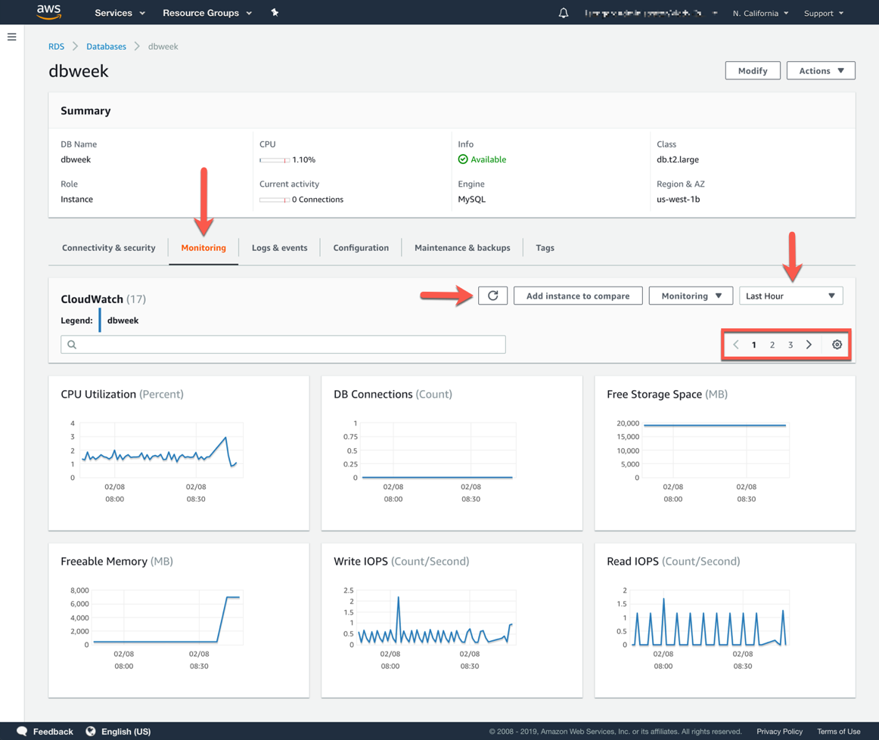

1. Use the **Refresh** button (circle with arrow) to repopulate the graphs with new data. You can also change the time period of the graphs from **Last Hour** to other relevant ones.
2. Monitoring metrics are paginated due to the large number of options, use the pagination controls to cycle through them, or change the number of graphs displayed on one page.